Sprint Retrospective – Sellers Crum

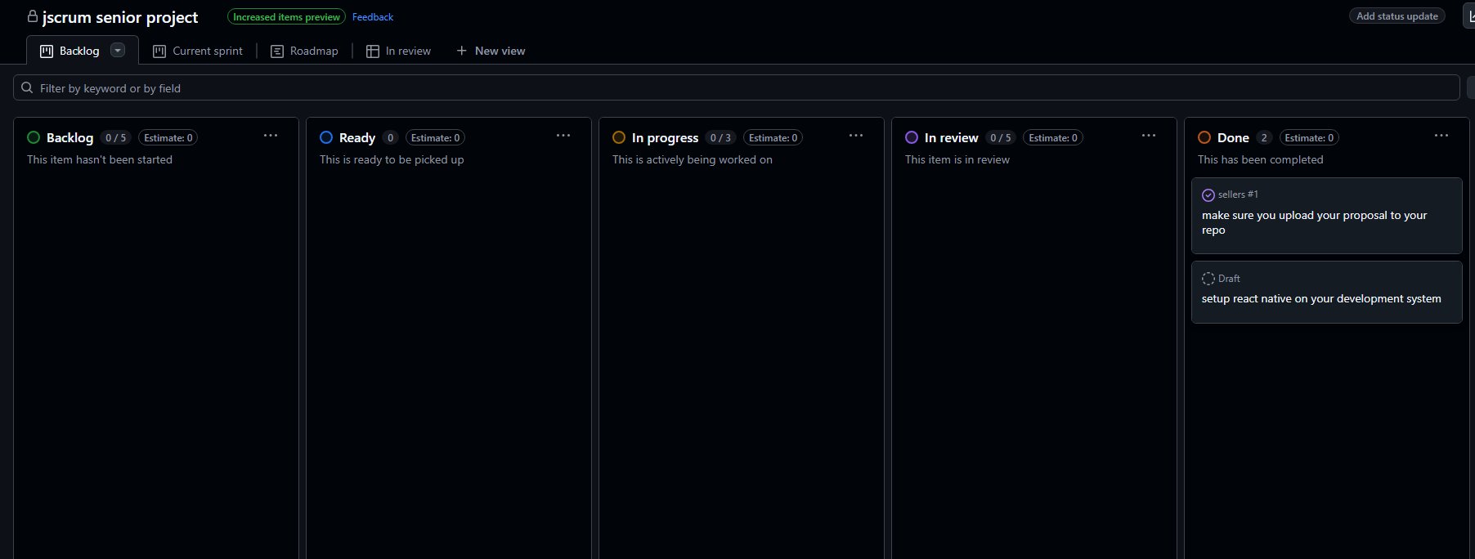

Project Title
MyBikeTrafficApp

Sprint Number
Sprint 1

Sprint Duration
Feb3 – Feb 17

Date of Retrospective
Feb 2

Sprint Goals
Set up react native and complete proposal draft

Accomplishments
Both goals were accomplished in this sprint

Challenges
React native is a complex application to get setup. Needed help from Dr. Toone.

Next Steps
Continue development of app layout.

